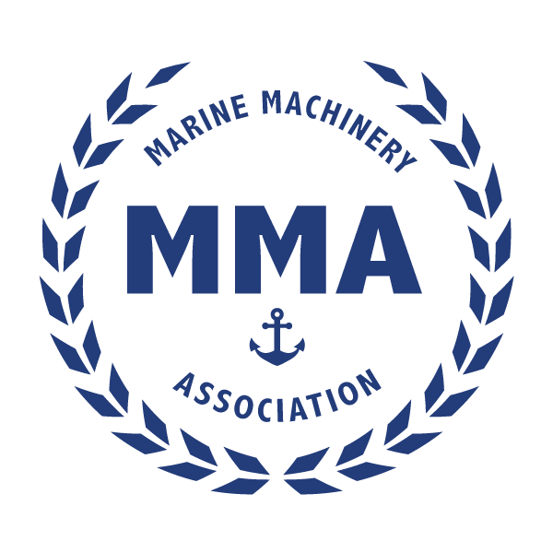
`
A reception for Members, Speakers, and Shipyard Attendees
will be held at the Westin - Tuesday Night January 20, 2024

February 21, 2024
Westin Crystal City at Reagan National Airport
1800 Richmond Highway
Arlington, Virginia 22202

Preparing for the Future Fight
39th Annual
Spring Meeting

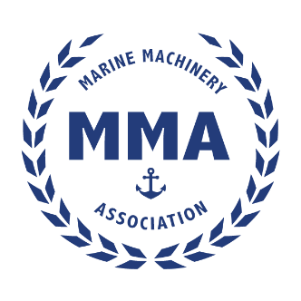 | Advance Registration for MMA’s  2024 Spring Meeting  Register by February 1, 2024, for a Special Price!  There will be no onsite registration - seats are limited - register early!
Please type or print. One (1) registrant per form.
First Name, Middle, Last Name (exactly as shown on your ID)  Click here to enter text. |  |  | Nickname  Click here to enter text.
Company  Click here to enter text. |  |  | Title  Click here to enter text.
Street Address

Click here to enter text.
City  Click here to enter text. | State  Click here |  |  | Zip Code  Click here | Country  Click here
Phone Number(s)  Click here to enter text. |  | Corporate Website  Click here to enter text.
E-Mail Address:  Click here to enter text. |  |  | Driver’s License or Retired Military ID #  N/A
This meeting is open to US Citizens Only

Registration Fees: For accurate accounting purposes, please check the amount you are paying. | Through February 1 | After February 1
Members | $600 | $650
Non-Members | $700 | $800
Speakers | Free | Free
Please make checks payable to: Marine Machinery Association
Mail Completed Registration to: 8665 Sudley Road, Suite 270, Manassas, VA. 20110
Or Fax to : (703) 791-4808
Please Note: For Credit Card Use - Information Required*
*Name on Card Click here to enter text.
*Billing Address Click here to enter text.
*City, State, ZIP Click here to enter text.
*Type of Card: AMEX ☐ MC☐ Visa ☐(Check One)
*Account Number Click here to enter text.
*EXP Date Click here to enter text.*Auth. CodeClick here to enter text. (For all Credit Cards)
*Email for RECEIPT Click here to enter text.
- Confirmations: MMA will email Registration confirmation to you within 7 days of receipt.
- Cancellations/Refunds: Written notification of cancellation must be received prior to February 1, 2024, to obtain a partial refund (a $100 administration fee will be retained). Thereafter, no refunds will be made.
- Questions? – Direct questions to Leslie Richard at (703) 791-4800, fax at (703) 791-4808, e-mail at Lrichard@marmach.org.
- Address: 8665 Sudley Road, # 270, Manassas, VA 20110
Room Block
Rate $193
Book your group rate for Marine Machinery Association - February 20 - 22, 2024

